Java Installation Process

1. Click on the java software
2. Install one
3. Write click on this PC and select properties

4.click on advance system setting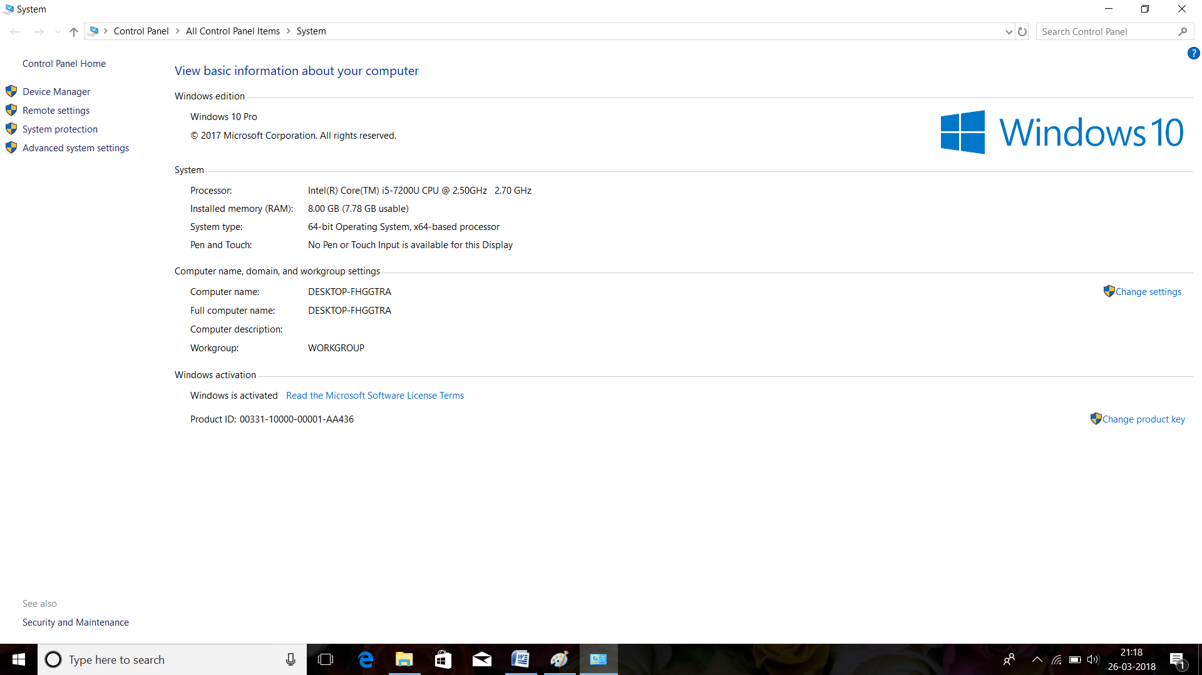

5

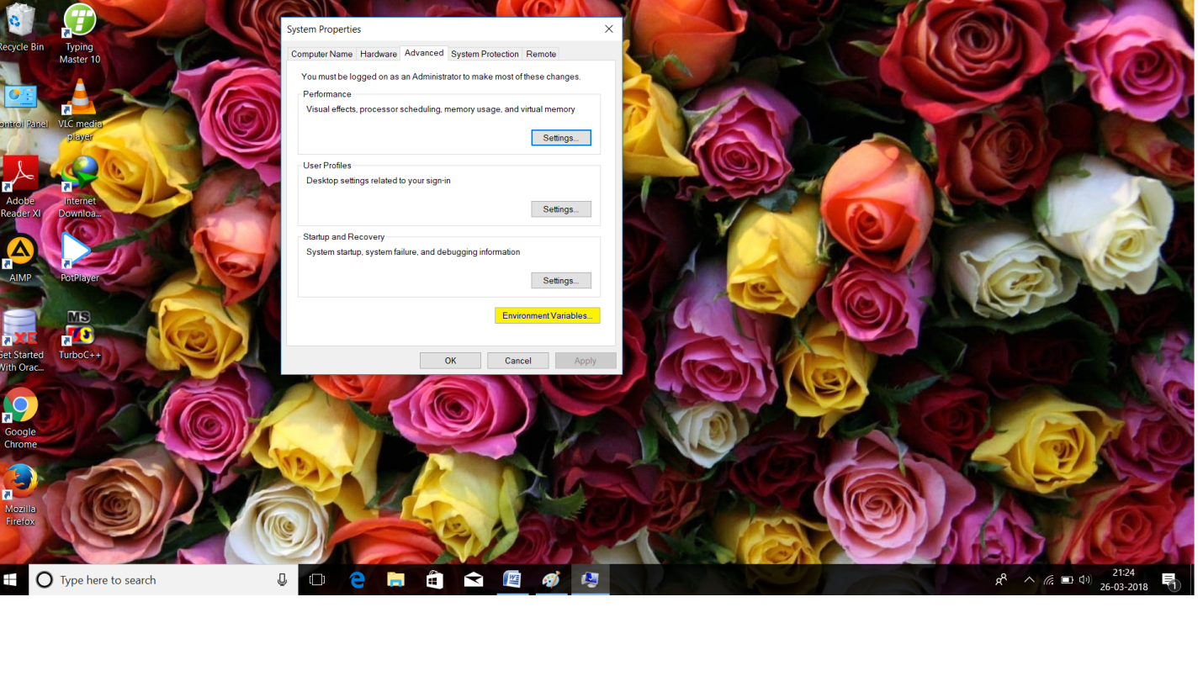

6.Go to the environmental variables this type of dialog box will be open

